# **WIRE FRAMES**

**Table of Contents**

**WIRE FRAMES** 1

**1.** **LOGIN PAGE** 1

**2.** **HOME PAGE** 2

**a)** **STAFF & QA coodinator** 3

**b)** **ADMIN & QA Manager** 3

**3.** **PROFILE** 5

**4.** **NEW POST** 6

**5.** **LIST CATEGORY** 7

**6.** **CREATE CATEGORY SECTION** 8

**7.** **ADMIN CREATE** 9

**8.** **CREATE EVENT** 10

**9.** **CREATE ACCOUNT** 11

**10.** **LIST ACCOUNT** 12

**11.** **ANALYSIS** 13

1. **LOGIN PAGE**

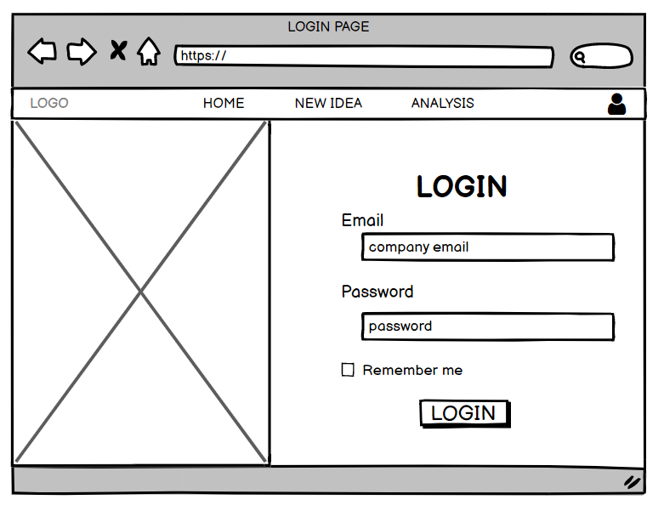

|  |  |  |  |
| --- | --- | --- | --- |
| No | Item | Description | Constraint |
| 1 | Text bar | Enter suitable information | Can’t be left blank |
| 2 | Check box | Click it to allow the next login without enter password again |  |
| 3 | Login button | Click to login the website |  |

1. **HOME PAGE**
2. **STAFF & QA coodinator**

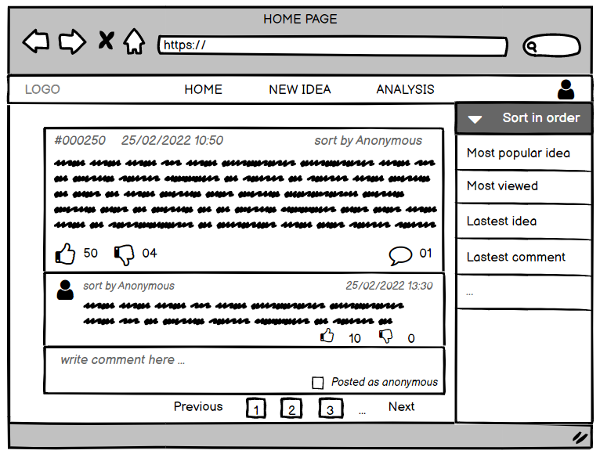

|  |  |  |  |
| --- | --- | --- | --- |
| No | Item | Description | Constraint |
| 1 | New idea | Click to create new post | Must agree term & conditions |
| 2 | Analysis | Click to show statistical analysis of current events |  |
| 3 | Sort in order button | Click to display in the order you choose |  |
| 4 | Pagination button | Click to move to another more posts |  |
| 5 | Profile icon | Click to show owner information or log out |  |
| 6 | Reaction icon | Thumbs up to like post and thumbs down to dislike post | Only once for any idea |
| 7 | Comments | You can write your opinion below the post |  |
| 8 | Anonymous checkbox | Click that if you want to hide your information |  |

1. **ADMIN & QA Manager**

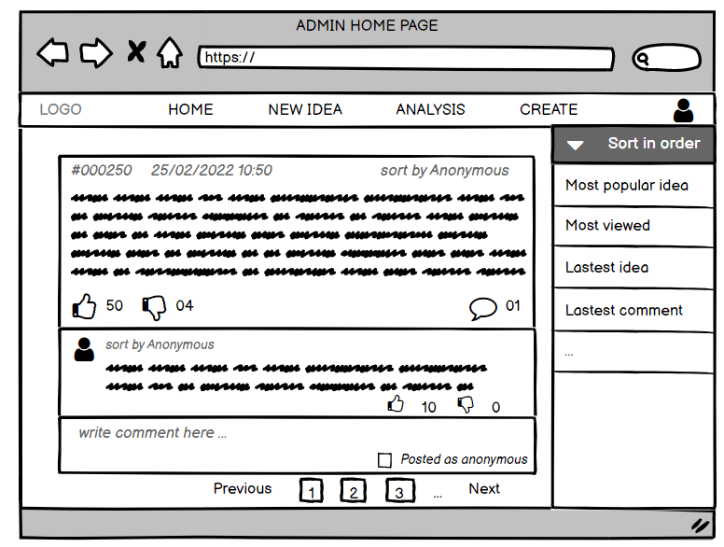

|  |  |  |  |
| --- | --- | --- | --- |
| No | Item | Description | Constraint |
| 1 | New idea | Click to create new post page |  |
| 2 | Analysis | Click to show statistical analysis of current events |  |
| 3 | Create | Move to the create page (just for admin) |  |
| 4 | Sort in order button | Click to display in the order you choose |  |
| 5 | Pagination button | Click to move to another more posts |  |
| 6 | Profile icon | Click to show owner information or log out |  |
| 7 | Reaction icon | Thumbs up to like post and thumbs down to dislike post | Only once for any idea |
| 8 | Comments | You can write your opinion below the post |  |
| 9 | Anonymous checkbox | Click that if you want to hide your information |  |

1. **PROFILE**

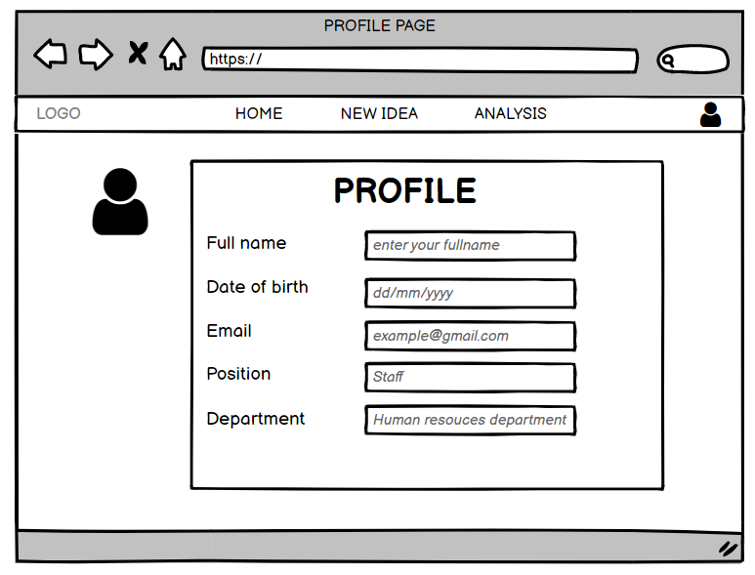

|  |  |  |  |
| --- | --- | --- | --- |
| No | Item | Description | Constraint |
| 1 | Text bar | Show suitable information | Staff can not edit information |
| 2 | Person icon | Show your image | Staff can not edit information |

1. **NEW POST**

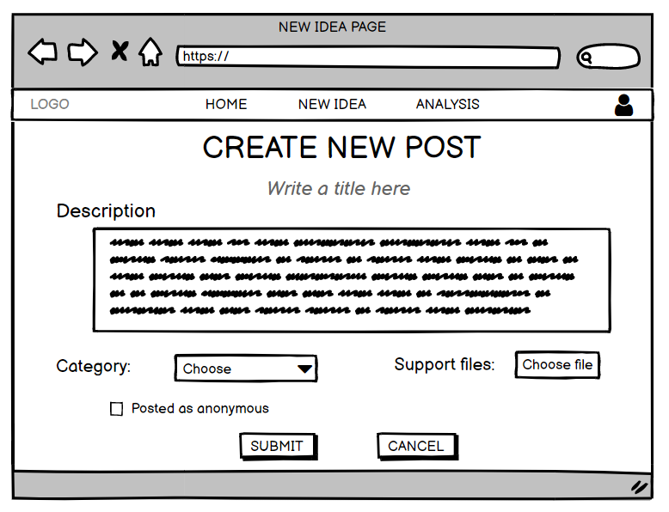

|  |  |  |  |
| --- | --- | --- | --- |
| No | Item | Description | Constraint |
| 1 | Text bar | Enter suitable information |  |
| 2 | Category | Choose the category that matches the content of your post | Must choose if you want to submits |
| 3 | Support files | Click to update *file.zip* as evidence to support your opinion |  |
| 4 | Anonymous checkbox | Click that if you want to hide your information |  |
| 5 | Submit button | Click to post your idea | Must agree Term & Conditions |
| 6 | Cancel button | Click to turn back home page |  |

1. **LIST CATEGORY**

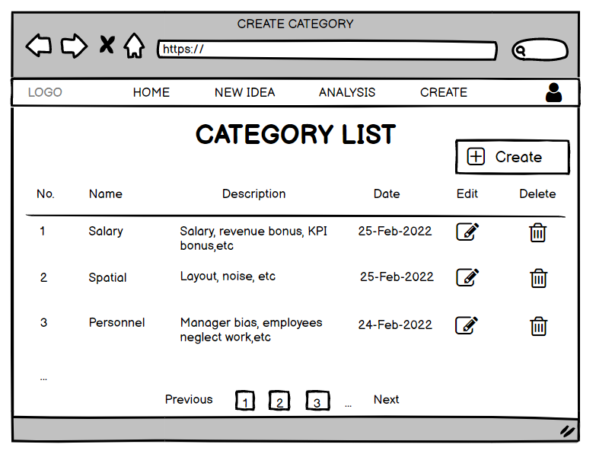

|  |  |  |  |
| --- | --- | --- | --- |
| No | Item | Description | Constraint |
| 1 | Pagination button | Click to move to another more posts |  |
| 2 | Create button | Click to create new category |  |
| 3 | Edit icon | Click to change information |  |
| 4 | Delete icon | Click to delete information |  |

1. **CREATE CATEGORY SECTION**

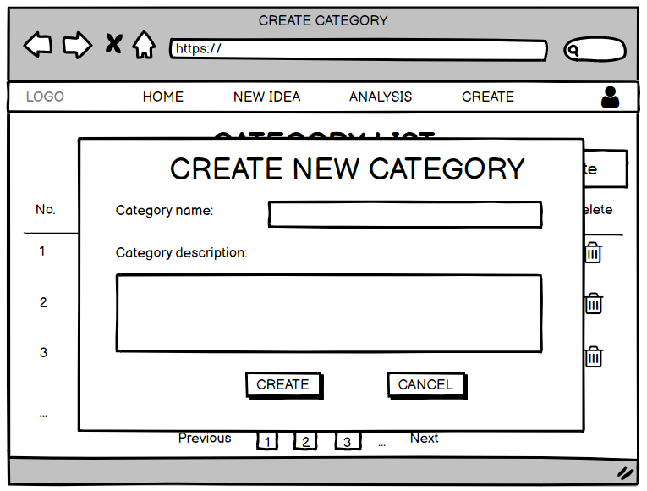

|  |  |  |  |
| --- | --- | --- | --- |
| No | Item | Description | Constraint |
| 1 | Text bar | Enter suitable information |  |
| 2 | Create button | Click to create category |  |
| 3 | Cancel button | Click to turn back category page |  |

1. **ADMIN CREATE**

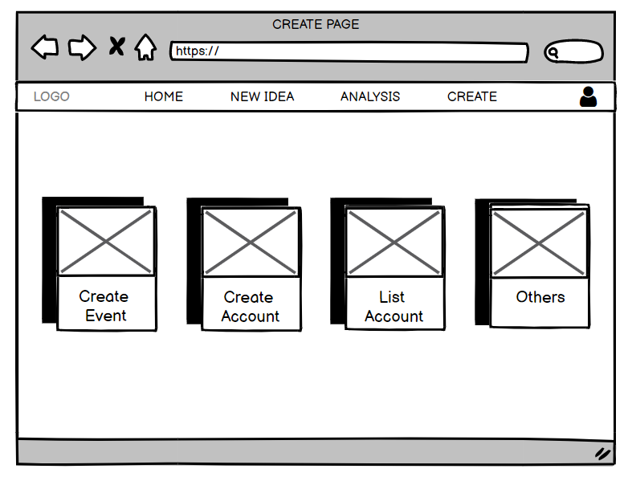

|  |  |  |  |
| --- | --- | --- | --- |
| No | Item | Description | Constraint |
| 1 | Create box | Click to switch to the corresponding page |  |

1. **CREATE EVENT**

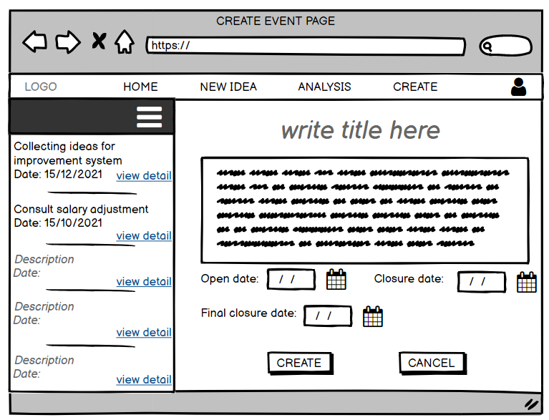

|  |  |  |  |
| --- | --- | --- | --- |
| No | Item | Description | Constraint |
| 1 | View detail link | Click to show history event detail |  |
| 2 | Text bar | Enter suitable title |  |
| 3 | Date button | Click to set up date for event |  |
| 4 | Create button | Click to create event |  |
| 5 | Cancel button | Click to turn back create page |  |

1. **CREATE ACCOUNT**

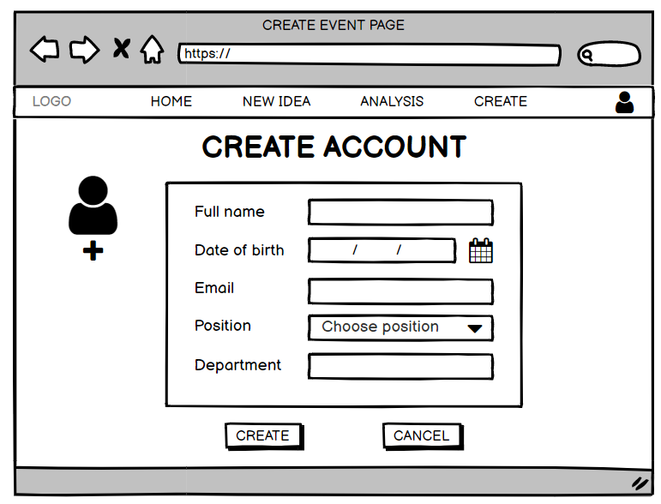

|  |  |  |  |
| --- | --- | --- | --- |
| No | Item | Description | Constraint |
| 1 | Text bar | Enter suitable information |  |
| 2 | Person icon | Click to update user image |  |
| 3 | Create button | Click to create account |  |
| 4 | Cancel button | Click to turn back create page |  |

1. **LIST ACCOUNT**

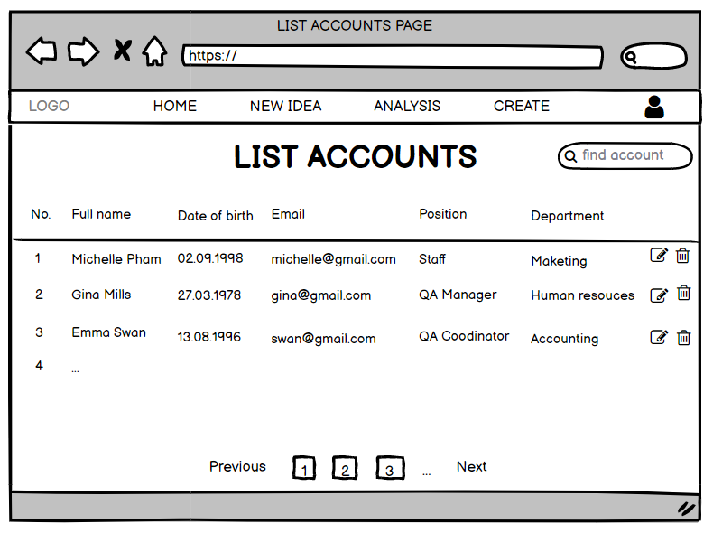

|  |  |  |  |
| --- | --- | --- | --- |
| No | Item | Description | Constraint |
| 1 | Pagination button | Click to move to another more account |  |
| 2 | Search box | Enter user name to find account |  |

1. **ANALYSIS**

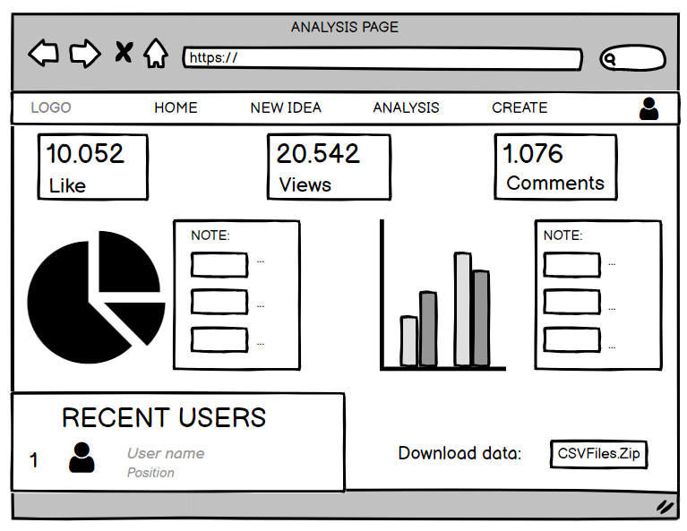

|  |  |  |  |
| --- | --- | --- | --- |
| No | Item | Description | Constraint |
| 1 | Like box | Show the total number of people who liked the post |  |
| 2 | View box | Show the total number of people who saw the post |  |
| 3 | Comment box | Show the total number of people who commented |  |
| 4 | Chart & note | Show the analysis that the event needs to summarize |  |
| 5 | Recent users | Show recently created users |  |
| 6 | Download button | Click to download data (for QA) |  |